Own Liberty Radio Station for $120 – Guest post by Cash Newmann, 2017 update
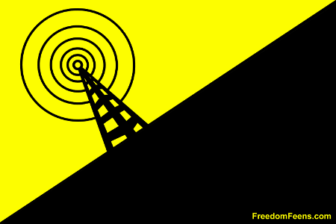
(Get your 3 foot x 5 foot Freedom Feens radio flag for your radio studio HERE for 16 dollars)
Guest blog post by Cash Newmann
BEFORE YOU START,
1. MAKE SURE YOUR TOWN HAS AT LEAST ONE OPEN FREQUENCY. Here’s a site that helps you find one if you’re in the USA, searching by zip code:
http://radio-locator.com/cgi-bin/vacant
then use your radio to make sure there’s not already a community station on that frequency.
If there’s no open frequency in your town help someone else get this done in their town, because if there’s no open frequency in your town and you try to broadcast:
–Your station will be un-listenable because there will be other material playing at the same time.
–You’re likely to get your door kicked in and face fines.
SO, YOU WANNA BROADCAST LIBERTY MEDIA ON THE RADIO?
I’ve seen a lot of posts on FM micro-transmitter systems, but they’re all lacking in this detail or that. For instance, a lot will vaguely say what kind of gear you need, but then don’t say where to get it, or diagram how to set it up your gear chain, or specifically say what adapters you need. I made this post to fill a void. This post includes details of ALL parts needed, direct Amazon links to order them, how to set them up and configure them, as well as a lot of related information based on extensive testing.
The advantage of using Amazon, of course, is they have protections on anything you order, and they will make it right if it goes wrong, even from a third-party shipper.
DISCLAIMER:
I’ve experimented with the transmitters below, so this is from first-hand experience. But I did it on a boat, 200 miles from shore, in international waters. I do not own any of this gear, I sold it to some church folk at a gun show after I was done testing it. And I am not currently transmitting. I’m just passing on information, in a theoretical capacity, for educational purposes only. Nothing here is legal advice, I am not a lawyer. I take no responsibility for anything you do or anything that happens as a result of doing anything listed below. ALL OF THIS IS FOR EDUCATIONAL PURPOSES ONLY. DO NOT DO ANYTHING SHOWN HERE. EVER.
Also, any fires, injury, inconvenience or anything else caused by a transmitter you use is not my problem.
First question: WE HAVE THE INTERNET. WHO NEEDS RADIO?
Podcasting is cool, but radio can reach people who would never find a given podcast…those who are not Internet savvy, or even people who are who Internet savvy, but just dig radio. There are millions of people like that. And there are a lot of folks who channel-flip while driving (especially when stuck in traffic). Inexpensive low-power community radio can reach those people, bringing them a voice of true liberty, and ideas they’ve likely never even encountered.
Radio is low-tech and almost like magic. It’s worked well for a hundred years, and is still going strong despite the flourishing Internet.
Besides, radio is fun. There’s a thrill you get from being in your car listening to something you put out without the nerding around of the Internet. Other people who listen to your show will grok that thrill too.
And no one can track radio listeners. (Though a really dedicated person with resources can track the transmitter. But we’ll tell you ideas on how to avoid that.)
Time was when non-profit groups in America could get a license for a community radio station of up to 100 watts, which can more than cover a large city or even a county. But a while back, the gub’mint sold out to a very small number of huge corporations who help write and pass the laws, and each own most of the radio and TV stations in every town. These government-backed monopolistic conglomerates fired all the DJs, replaced them with computer-automated DJ bots with songs picked by tin-eared business dorks.
And nowadays, when there are real (nationwide) hosts, many of the people calling in are coached, paid actors pretending to be real people. The conglomerates kicked out the free thinkers, riddled the shows with cheesy ads and “news” that only exists to drive horizontal enforcement of statism. That’s why every station in every town sounds the same, plays the same horrible music or horrible talk hosts, and sounds like they choose what to play based on math and marketing and keeping people sheepish, rather than taking chances and making decisions based on taste or real freedom.
In the USA, you can legally transmit on an open frequency if it’s basically not strong enough to reach past your yard and maybe your next-door neighbor’s yard (what Dale Gribble on “King of the Hill” called “the most powerful station in the tri-yard area.” lol.) This is called Part 15 Broadcast. That name is based on the part of the document with all the damn rules. (They are rules, not laws. Laws can only be passed by Congress. These are rules written by bureaucrats who try to get them enforce as if they’re laws.)
While the Part 15 limits are based on a number of factors, including transmitter output wattage, antenna size, antenna type and antenna height, basically if you’re broadcasting at 100 mW (1/10th of a watt), you’re within the spirit of the rules, which will usually keep you from getting hassled, especially if your production quality is good and you do not cuss. (Both are important at any wattage.)
While using a radio transmitter on an unused frequency for community radio is a clear natural right, as well as use of the First Amendment of The Constitution of the United States (that the United States is supposed to abide by), the pen-pusher fed goons don’t like it. They make part of their living selling permission slips to transmit, and they rake in billions from this.
Also, there is a long tradition of transmitting freedom propaganda into occupied territory, such as the USA’s ongoing Radio Free Europe, which violated Soviet law to transmit into the USSR and into East Berlin during the Cold War. They still do this all over the world, while at the same time, preventing us from doing the same here, AND trying more and more to regulate what we say and do on the Internet. The USA is now occupied territory….The Occupied States of America, with a cop on every corner, and no respect for Natural Rights or the Constitution (not that *I* ever signed that thing). If the Occupied States of America thinks it’s their right, shouldn’t it be your right too?
While many citizens do run transmitters at far more than 100 mW for YEARS without getting in trouble, breaking the law is bad, um’kay? We do not recommending you break any laws, even nanny laws! We have a social contract. Abide by it or society will degenerate into anarchy!
Many countries do not have the same draconian radio laws as the US (“land of the free”, my ass), so I’m gonna tell how they do it in other countries. DO NOT RUN A TRANSMITTER ABOVE 100 mW IN THE USA. YOU PROBABLY WOULDN’T GET IN TROUBLE IF YOU WENT WAY ABOVE THAT LIMIT, EVEN RUNNING 7 WATTS OR MORE, BUT BE A GOOD BOY OR GIRL AND OBEY ALL LAWS! The social contract depends on it!
Here’s some good gear you’ll need to get started. Total price, $87:
$55 Signstek 0.5 W Transmitter. Get it here on Amazon:
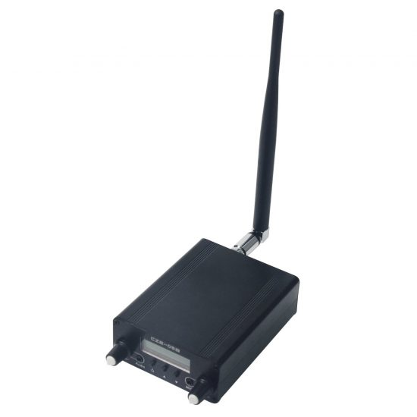
It a has built-in low-pass filter, so you do not need to add one.
Below are all the controls (this is from a different transmitter, but all the controls are the same):
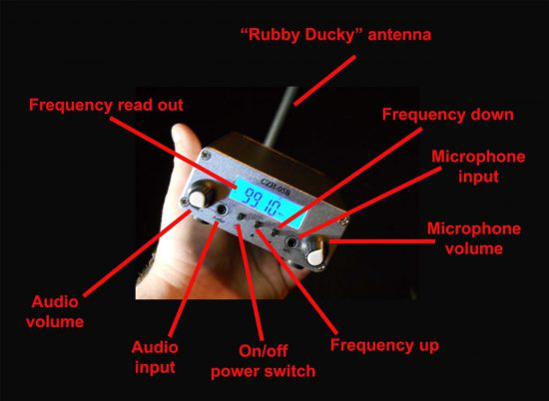
The power cable on these transmitters is about 5 feet long. You may need an extension cord, but you probably already have one.
STRONGER TRANSMITTER (for non-USA use, they are not legal in the USA).
Signstek 7W FM Transmitter Mini Radio Stereo Station PLL LCD with Antenna. Has built-in low-pass filter.
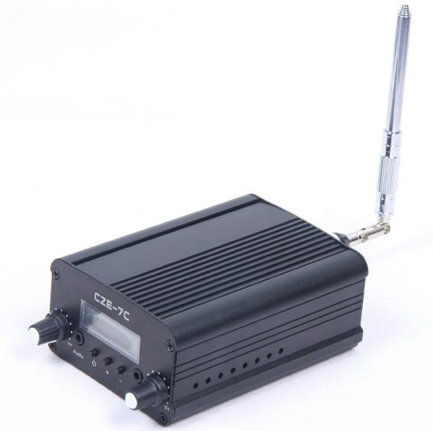
You won’t get much range with the attached antenna on either of these transmitters. They’re not designed for range, and you Won’t have it up very high just sitting by a window in your apartment, unless your apartment is higher up than most of the buildings around you. In that case, it might work 2 to 4 blocks. But you can broadcast much farther:

MUCH BETTER ANTENNA:
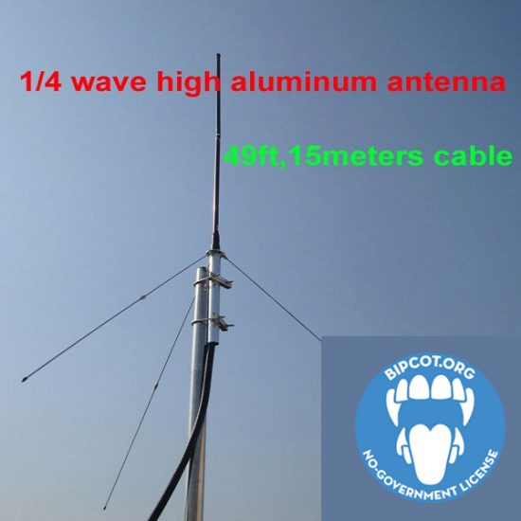
$54 Zowaysoon ¼ wave Professional GP Antenna with cable. If you can mount it on a roof or in an attic and want to GREATLY increase your range.
It’s about 30 inches high and 30 inches wide when assembled.
That picture says the included cable is longer than it actually is (its from a different website). It actually is 26 feet.
Connector type on the end of the cable BNC (NOT TNC) Male:
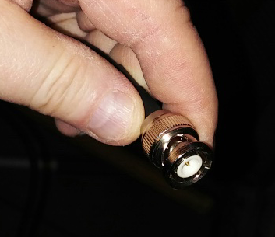
You’ll need This $6 TNC male to BNC female adapter to connect the included antenna cable into the back of your transmitter:
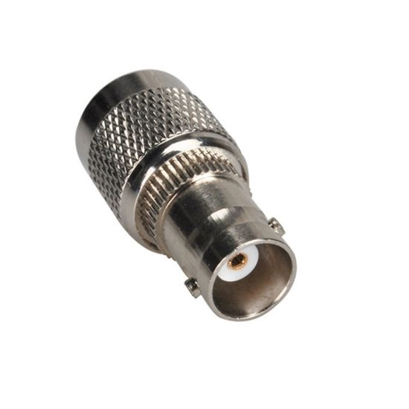
The antenna does not include any directions. Basically all you need to put it together is a Phillips head screwdriver, and a couple pairs of pliers or vice grips. Don’t turn the threading too hard, you’ll strip it. It’s aluminum. It’s rather soft, but the whole antenna is resilient because it flexes in wind, and it also will not rust.
These pictures will help you with putting it together.
Unscrew the screw near the heavy base with a Phillips screwdriver to remove the base, pull the cable through the tube, screw the cable in carefully (note there are two little points in the make end that go in the grooves in the female end).
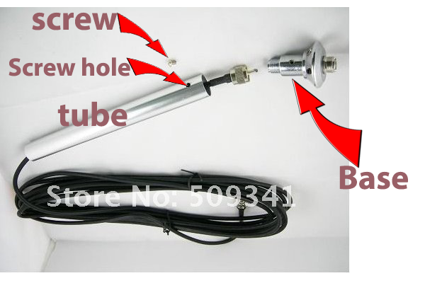Then screw the base back in to the tube, and screw the screw back in with a screwdriver.
Then attache the silver-colored aluminum thin poles into each other then into the base pointing down:
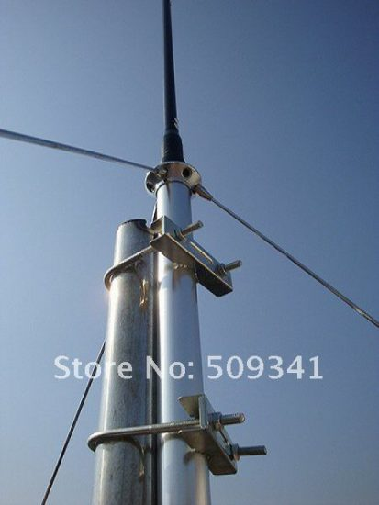
Then attach the one black pole with no markings on it to the top of the base.
Then into that black pole with no markings screw the proper antenna top. It comes with five:
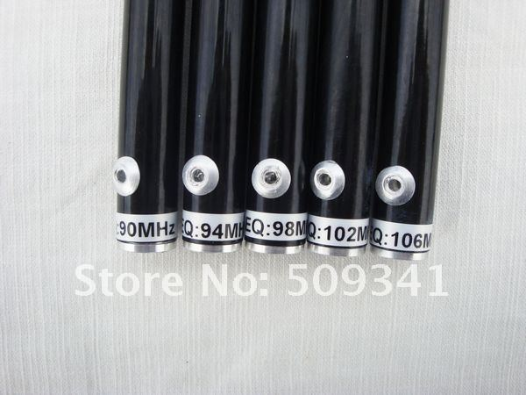YOU DON’T USE ALL OF THESE, YOU ONLY USE ONE. You’ll end up saving 4 in a drawer in case you ever have to change frequency. Only use the one with a frequency closest to what you broadcast at.
Like if you broadcast at 105 Mhz, use the one that says FREQ: 106 Mhz on the bottom.
If you broadcast at 95 Mhz, use the one that says FREQ: 94 Mhz on the bottom.
Then screw in the u-mounts on a roof or pole to attach to a pipe or other mount. Secure the cable down (don’t staple deep enough to cut it) on the roof and into the house or wherever you keep your transmitter.
This antenna really is a flamethrower of radio energy. Don’t have it too close (like under 10 feet) to the transmitter or it might feed back.
Having the antenna in the attic of a second-story building is a great idea, because it won’t be seen from the street.
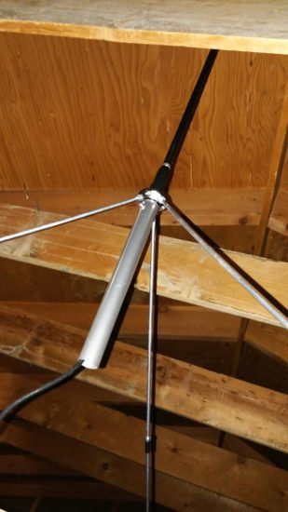The roof, if it’s not metal, will not block out very much of the frequency, maybe 20% tops. Having it inside an attic on the second floor will reach much further with your transmitter on high setting than these transmitters will reach on low setting on the outside of the roof.
If there’s not room enough to mount the antenna on a pole in the attic, you can gently let it rest on the 3 metal poles pointing down, like a tripod. (2 of 3 visible in this photo sent in by a fan.)
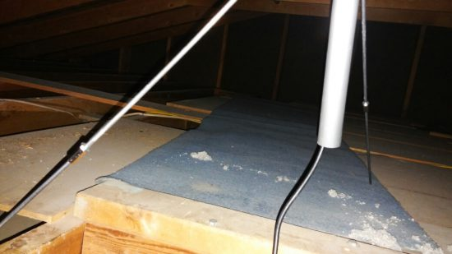If one of the holes gets stripped, you can screw one of the the bottom poles into a non-centered screw hole without a lot of loss. The antenna will not stand up well if you do that, but you can lean it against a beam on the ceiling.
BE SURE TO WEAR A FACE MASK WHEN CRAWLING AROUND IN THE ATTIC! Many attics in older houses still have asbestos insulation. Exposure to asbestos can cause all kinds of health problems, including a form of cancer.
Even if it’s not asbestos but rather the refined paper kind of insulation (which looks very similar to blown asbestos, kind of like fluffy dried papier mâché, there’s a few tufts of it in the picture just above this paragraph), or if it’s fiberglass insulation, all of them can irritate your lungs.
And when you’re done up there, throw your clothes in the washer, take a shower and wash your hair. IMMEDIATELY.
If you actually go IN the attic, don’t step anywhere except on beams, or you may fall through the ceiling. You probably won’t need to though, placing the antenna can usually be done on a ladder with someone below holding the ladder for safety.
TIP: Do this when you’re sober.

ANTENNA DISTANCE:
If 26 feet isn’t enough to get to your transmitter, you can extend it using coax cables and the right adapters.

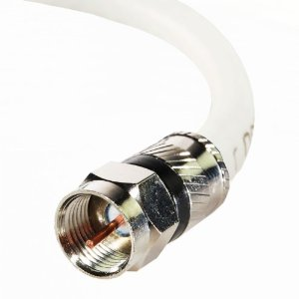
^$9 50-foot Dual Shielded Coaxial Cable – F Male to F Male
(If 50 feet is more than you need, get a 25-foot one. If you need longer, this will work with up to a 100-foot F to F male to Male coax cable.)
To use that you’ll need this $5 BNC Female to F Female Adapter:
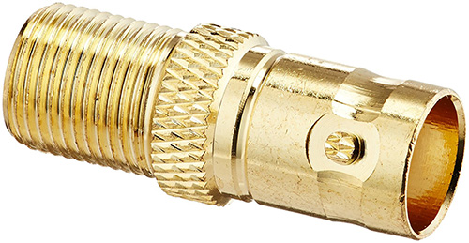
and
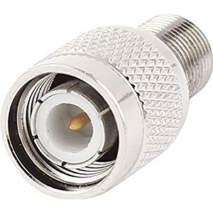^$7 TNC male to F type Female adapter.
(If those are sold out: TNC Male to F Type Female adapter (this purchase comes as a pair but you only need one of them.)
Those will connect your antenna, your coax cable and your transmitter.
If Amazon is out of any of these things at these links and you need to search for them from another vendor on Amazon, please use this link before you search on Amazon.
=-=-=-
If you get the signal up to the roof with coaxial, it will have MUCH more range than with the antenna inside your house, especially if you’re on the first floor. And especially if you’re up on a hill.
You can safely spray paint the the antenna, any non-metallic color to better blend in on your roof, without losing much or any range.
Make sure to spray paint outside, and do not inhale the fumes.
Be sure to tighten all jack connections. If they’re not tight they won’t fully make electrical contact. Use two pairs of pliers or vice grips to get them tight enough to work but not so tight you strip the threads.

SO YOUR TOTAL COST IS:
LOW-POWER SETUP:
Transmitter: $55
Best Antenna: $54
Adapter: $6
TOTAL: $115

HIGH-POWER SETUP
Transmitter: $60
Best Antenna: $54
Adapter: $6
TOTAL: $120

Adding a 50 foot cable to either, plus the two more adapters you’ll need:
$21 more.
If your an Amazon prime member, you’ll likely pay no postage too. If you’re not, figure about 10 bucks for postage.

SOME THINGS YOU WILL NEED BUT MAY ALREADY HAVE:
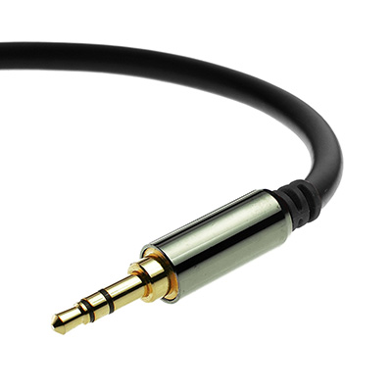
–^$6 Male-to-male stereo audio cable 3.5 mm (1/8 inch) to plug computer or iPod into transmitter.
(Only use a stereo audio jack to plug into the transmitter. A mono jack will mechanically damage the female jack in the unit.)
–Computer or iPod to play your programming from. Here’s a $20 MP3 player that has a shuffle feature:
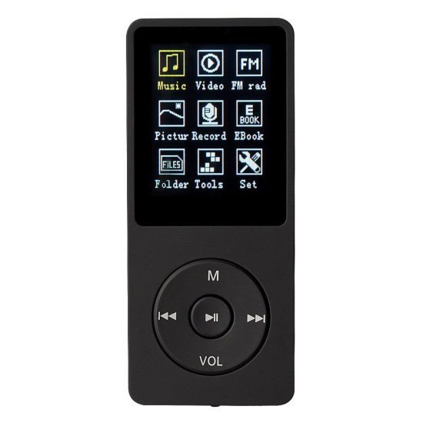
It’s inexpensive, solid, charges via USB and a charge lasts about 30-50 hours of full play, depending on volume (lower volume lasts longer) and the temperature where it’s running. (Cool is good but too cold will lower the time the battery lasts.) It only takes 2 to 3 hours to charge.
It’s a little wonky to use but if you read the Chinglish manual, all will be revealed. (The right-pointing button does what the Up button does on other players, and you must hold Volume button to get to change volume, then use right-buttton to raise it, and you must awkwardly navigate to the Shuffle to set it on shuffle, etc.)
A good volume setting is put the volume on 23, and have the transmitter volume at about 2 o’clock. To perfect the volume, adjust your transmitter volume so the volume on a radio receiver is the same as other FM stations below and above it on the dial.
Basically you set it on shuffle after attaching the included USB cable and moving a bunch of MP3s over to the Music folder.
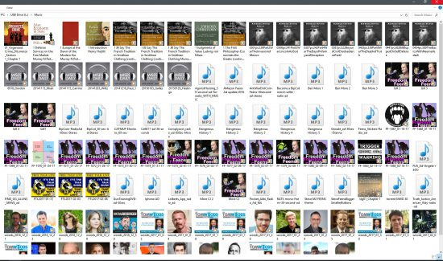

BUT I’VE SEEN ALL THIS EVEN CHEAPER ELSEWHERE!
A lot of transmitters on eBay (and Amazon) ship from Hong Kong, which is a crap shoot if you’ll even receive it. And if it’s defective, good luck returning it and getting your money back, if it even makes it through customs both ways. This article has links to hand-picked reputable American resellers. While they do charge a little more, it’s still cheap, and you’re sure to actually get it, actually get what you bought, and get it quicker. Also, if there’s a problem, you’re not screwed. (That is, if you’re in America. If you’re in Europe or elsewhere, you might be better off ordering from Hong Kong. But maybe not even then. I’d try your local Amazon instead.)

SOME TIPS FOR PROPER USE:
NEVER power up your transmitter without a proper antenna attached! Powering up your transmitter without a proper antenna attached will damage the transmitter. Use a proper antenna only, or you will fry your transmitter. Both the crappy antenna that comes with these transmitters, and the ¼ wave extra antenna we listed, are proper antennas for all of the transmitters listed here.
Running an FM radio receiver for too long in the same room with the transmitter can harm the receiver. Same house should be OK, but in the same room isn’t. Running other electronics should be fine, but don’t run an FM radio receiver in the same room as the transmitter.
To adjust the power output on these transmitters from 100 mW (possibly legal in USA, depending on your antenna and other factors) to 500 mW (not legal in USA), or to adjust the 7 watt transmitter (not legal in USA) to 1 watt (still not legal in USA), here’s all you need to do: Push in and hold the power-on button for 3 seconds. Then plug in the power cord. The LCD will read “H” (high, 500 mW on first transmitter, 7 watts on other transmitter) or “L “L” (low, 100 mW on first transmitter, 7 watts on other transmitter),
By using the frequency up & down buttons you can switch to L or H, then unplug the power cord, then plug the power cord back in, hit the power button to turn the unit on, and you are now broadcasting at Low or High power, which ever you want.
Legally I have to recommend that you don’t turn the power up to 500 mW unless it’s the zombie apocalypse and you have to warn your neighbors of the threat. 100 mW can give you a range of less than a block (with rubber ducky antenna indoors). It can reach about two blocks in all directions (with rooftop ¼ wave antenna). 500 mW can reach about 4 blocks (with cheap included antenna indoors) and over a mile and a half to two miles with a rooftop ¼ wave antenna. (That’s line of site with the antenna. It more or less stops dead when it hits a big hill or a line of tall buildings.) In an urban area, two miles each way is 16 square miles which is is potentially 250,000 people who live within the broadcast area, plus many more who drive through (and may be stuck in traffic if you live near a freeway). One of these transmitters can cover a medium-sized college campus plus off-campus areas where students live, shop and hang out.
It’s even possible to broadcast to a rectangle of ten miles by four miles with 7 watts. I know a guy in England doing that. He’s on a low hill, and has the antenna in the attic of a three-story wooden house. INSIDE the house, not on the roof. He has great line of sight to his whole broadcast area, and there aren’t many buildings taller than where his antenna sits. He’d probably broadcast even further with the antenna on the roof, but doesn’t want to “stand out.” He’s getting five miles each way in two directions, and two miles each way in the other two directions.
On the off chance you get a knock at your door, I would not let them in without a warrant, and one should stop transmitting. Do the same if you get a nastygram (cease-and-desist letter).
If you want to lower the chances of getting in trouble, you need to make sure you’re being a good neighbor to your fellow broadcasters (and to your neighbors. If you don’t follow all of this, you could even interfere with cell phones, wireless internet and ham radio operators near your house):
1. PICK AN OPEN FREQUENCY. Again, here’s the site that helps you find one if you’re in the USA, searching by zip code:
http://radio-locator.com/cgi-bin/vacant
Once you’ve found a frequency, drive around listening just to verify it’s clean. “Stepping” on an existing broadcaster is a sure way to get a visit from the goons. Treat your fellow broadcasters as you would like to be treated!
If you don’t have a car radio, or don’t have a car, here’s a 20-dollar portable FM radio for checking for open frequencies, and for listening to your show once it’s up:
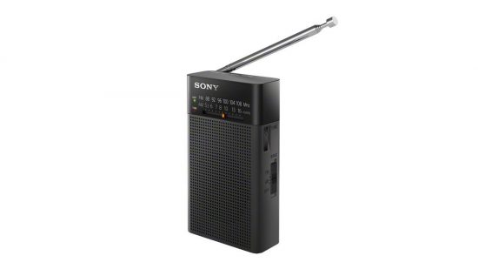Keep in mind this isn’t nearly as good of a receiver as most car radios. So anywhere you can hear your show on this, a car radio will pick it up further.
Some phones have FM receiver chip capabilities. Some don’t. Even some high-end phones don’t and sometimes cheap phones do. If your phone does, you will likely have a per-installed receiver app, usually called “FM Radio.” If you don’t see that you can try installing this free FM receiver Android app, NextRadio. If your phone does not have the chip, you’ll be told that during the installation.
With any installed FM app, the headphones act as the antenna. You have to have headphones plugged in for it to work. You can switch to the speakers if you want, but you have to have the headphones plugged in. Usually the app will have an option to switch to the speaker.
(Note: there a lot of apps that have the word “radio” or even “FM radio” in the app name that do NOT receive radio, they are “internet radio” apps, i.e. streaming talk or music media apps.)
2. MAKE SURE THAT YOU ARE RUNNING A TRANSMITTER WITH A BUILT-IN LOW-PASS FILTER! Other than picking an open frequency, this is ABSOLUTELY THE MOST IMPORTANT THING I CAN TELL YOU. This prevents your transmitter from splattering itself all over different frequency multiples via “Harmonics”. Meaning, if you are operating a cheapie transmitter with no low-pass filter at 100MHz, then you are also broadcasting at 200MHz, 400MHz, and so on. This is NOT being a good neighbor, and you may be interfering with other communications on other bands even though 100MHz might have been a clear channel.
All the small made-in-China transmitters listed here are incredibly inexpensive, and represent a great leap in technology and price from any previous transmitters that can solidly hold on one station with no drift. Many others like them do NOT have built-in low-pass filters, so you need to add one between the transmitter output and the antenna, which is more expensive than buying one of the two I list in this article that DO have the low-pass filter built in.
3. Use the line (Audio) input, not the microphone input. You can even epoxy the mic input shut and volume in place so you’ll never forget. A fan sent in this pic:
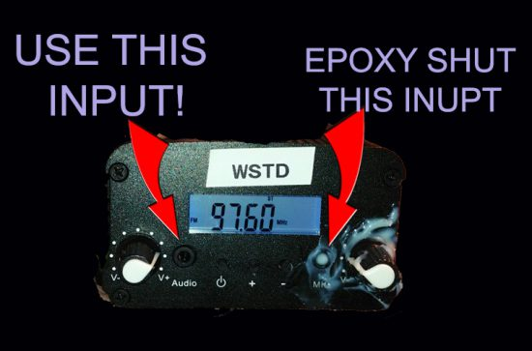
4. Don’t have your audio output volume too high from the computer or iPod that’s running into the audio input of the transmitter. Check the volume of transmission on a car radio a block from your transmitter. It should be comparable with commercial stations. NEVER louder. (And not quieter.) Audio material with consistent dynamics, i.e. a close-to-even volume, is better to use than audio material with lots of dynamics.
5. Don’t use material with cussing, that’s what gets people shut down. The gub’mint doesn’t actively monitor the airwaves, they generally only act on complaints from snitches. If you’re not cussing and not interfering with another station (remember, PICK AN EMPTY FREQUENCY and USE A TRANSMITTER WITH A LOW-PASS FILTER!) you’d likely be OK. Especially if the material you broadcast is professionally produced, even if on no budget. (Read http://www.creamyradioaudio.com/ for more.) Also, play it so it’s not distorted, and at the same volume as other stations you can get on your radio. Basically, you want the random nanny stater channel flipping to find it indistinguishable from other talk stations, except in topic.
TIP ON HAVING CLEAN, NON-DISTORTED AUDIO:
Practice “gain staging”, i.e. experiment with the right combination of volume settings on the MP3 player and the transmitter. You’ll generally get a cleaner broadcast if you have them both in the middle or 2/3 up than if you have one all the way up and one almost off.
The goons are mostly busy chasing down cell phone jammers these days anyway. The goons generally issue a cease-and-desist letter for the first few infractions, then threaten fines. They really don’t want anyone to take it to court, for fear it will make it to the Supreme Court and they might lose on First Amendment grounds, which would open a hornet’s nest for them, and spread a lot of liberty. So they really just want to scare you. If you get a nastygram, ship your gear to a friend in another town that has an open frequency.
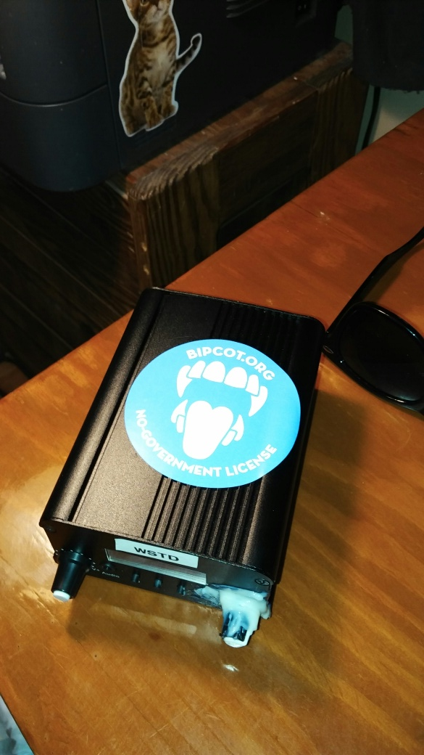
WHAT TO BROADCAST if you don’t have your own material, or enough to fill 24-7.
This podcast, the Freedom Feens
http://www.freedomfeens.com/
is the very best an-cap liberty podcast in the world. It’s funny, smart, has a large following, and is produced with very high audio quality, and with limited dynamics, which is perfect for radio. It’s also released covered by the BipCot NoGov license.
This allows use and re-use by anyone except governments and government agents. There are no government guns for violators, only shame. So it’s cool with the Feens if you broadcast it. They’ve actually mentioned on their shows that they’re cool with people sharing it anywhere, any time.
You can also get the episodes via BitTorrent HERE.
Also good is the Liberty Radio Network.
LRN is like the libertarian/an-cap NPR, in that it’s 24/7 of well-produced, great and varied liberty programming. And in that some people like to leave it on in the background all the time. But unlike NPR, LRN actually allows and encourages people to share it anywhere they’d like.
HOWEVER, NOT ALL THE SHOW ON LRN.FM ARE cuss-free. If you want cuss-free only (less chance of offending snitches, and anyone can dig the sound if it’s cuss-free), get the few cuss-free shows that are on LRN, but just download individual episodes.
All these shows are cuss-free and have good audio too:
—Freedom Feens (RSS of episodes here) All episodes after May 11, 2013 are cuss-free, that’s when the Feens moved from podcast to radio.
–Bad Quaker. No longer producing episodes, but still has a great collection of very solid stuff. I’d recommend any of the collections:
- The Beyond Civil Disobedience Series
- The Complete Bad Quaker Series on WAR!
Some other great stuff with good liberty content and goo
- 5 cuss-free (edited) episodes of Dangerous History Podcast (must be unzipped)
- All Freedom Feens public-service ads. (must be unzipped)
- Tom Woods (website here) Download zip here.
- Mises Institute audio articles (website here) You can download the zip here (also has more Tom Woods). Mises Institute audio articles are beautifully produced, and very cool. I strongly recommend you include some of these no matter what.
- Ron Paul’s podcast. He’s our favorite ex-government thug. (Though Ron’s podcasts are recorded VERY quiet. But I’ll include some that are fixed and normalized in the torrent.)
- Neocash radio. Good show about real economics, particularly on blockchain stuff. But still very listenable even for people who are new to Bitcoin and other blockchain technologies. The show producers say of it “We avoid curse words, for branding purposes. That’s the way we want to brand the show. Currently, we aren’t on the FCC airwaves, so there might have been one or two that have slipped in past episodes.” So I’d recommend you listen to episodes before including them. But it’s great stuff.
- William Grigg Freedom Zealot is amazing. Audio is here.
- Jason Stapleton Program, good, solid, cuss-free minarchist talk show with good audio. RSS here.
Those shows are all cuss-free, solid, great audio, great content, and timeless. You could play any of them 20 years from now and they’d still ring true.
–Also mix in some more “daily news” stuff with the cuss-free radio show Free Talk Live (RSS of episodes here) though you’ll need to swap out episodes every few days and put in current ones. It’s less timeless and more like the daily newspaper of liberty.
Also keep in mind, they take calls and while the show sounds great, some of the callers have HORRIBLE audio and/or are insane. I can only take it in small doses. I’d use a mix of maybe 10 each of Freedom Feens, Bad Quaker, Tom Woods, Mises Institute audio articles and those Dangerous History edited cuss-free ones, then put in two current Free Talk Live shows, but swap them out weekly or more. And run the whole thing of all four shows on shuffle.
An easy way to start would be to run a mix of those shows, and then if you want start doing a one-hour show yourself one hour a week and then expand to one hour a day or more.
Or if you don’t want to do your own show, just help spread liberty by running a station and playing the above recommendations of material by other people.
To learn how to do good audio, READ THIS POST! (important): 20-Minute Audio School
Also, my friend made a GREAT video on getting good audio.
Read and watch those before asking any questions please.
ADVANCED OPTIONAL STUFF IF YOU’RE GOING TO DO YOUR OWN SHOW:
A compressor/limiter will reduce the dynamics in your spoken material, which is a good thing for making a professional-sounding radio show and for not having a signal that will splatter on other stations. Some Xenix mixers have built-in compression. If you can afford it though, get this one, the DBX 1066. Here’s a great article on compression in general.
Again:
http://www.creamyradioaudio.com/ is a great site for low- and no-budget audio tips.
Two great articles on preparing a room to act as a broadcast studio:
Quick and dirty sound conditioning.
Permanent Sound Conditioning in Three Hours for $250.
RANGE
An antenna outside a house will have better range than an antenna inside a house. An antenna on top of the house is best, though it could attract attention.
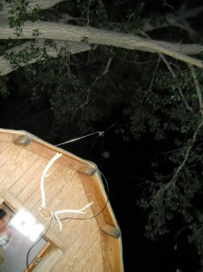Antenna on the roof of a garden shed. An actual “radio shack!”
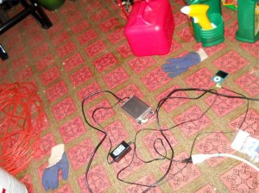System set up in a garden shed. And that’s not a gas can, that would be a bad idea near electronics. It’s weed killer.
Some people have been known to camouflage an antenna inside of PVC pipe, which does not attract as much attention on a roof as an naked antenna on a roof. This is because roofs, especially in cities, often have various tubes and pipes sticking out of them. The PVC will not cut down much on transmission power, but it will protect the antenna from the elements.
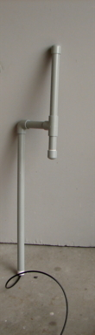Antenna inside a PVC housing.
If you have to have it inside, an antenna in the upper floors or attic of a building is better than on a lower floor.
But don’t have your transmitter up there, it needs a clear air flow to prevent fires. Keep the fan clear too, and don’t put anything flammable near your transmitter when it’s running.
An antenna in the basement is horrible. Near a window is better than not near a window. Inside a wooden house is better than in a brick house.
PRE-EMPHASIS
Long story short, these transmitters will sound better on receivers outside the US, they’ll sound a little trebley and “ssssssy” on non-digital US receivers. Not much you can do except pay a shot load more for a us-specific transmitter. Or canalize your transmitter and replace a few components and risk ruining the transmitter. Or deal with it. Or move out of Europe. (Trump’s wall is to keep you in more than to keep “them” out.)
For the tech info on pre-emphasis, go here.
If you have EQ on your source, you can try changing the treble a tiny bit. But make sure it doesn’t make it MORE sibilant, or harder to understand the words on the talkers on your shows. The WORDS are why you’re doing this!
INTERFERENCE
Even a transmitter with a low-pass filter can cause static on very nearby audio gear. If you have this issue, stop transmitting while recording, and use this time to recharge your MP3 player.
LOCATION:
An ideal location is any populated area, especially near college dorms or a near a highway with slow rush-hour traffic.
PROMOTION:
Stickers with your frequency, city, and some symbol of what you do, or the name of your show. Best to be mysterious and symbolic, to keep squares from groking what you’re up to. I don’t recommend graffiti, but I’ve seen it done. Also a small sign on a stick in the ground right next to a highway where there is slow rush-hour traffic. The sign could even just be the frequency number and “FM.”
TRANSMITTER LONGEVITY:
If you run your transmitter 24/7 and it gets warm, have a fan blowing on it to keep it from overheating. Put something under each edge of it so air from the fan can get under it, too.
AUDIO PLAYER SOURCE:
You might want to run your media from a spare computer using iTunes or Windows Media Player or other player, set on random shuffle. It doesn’t take a very powerful computer to do this, so you can use the old one you replaced a few years ago. Or whatever Linux people use. If you use Linux, you probably know what to use.
SAFETY:
I’d keep the antenna away from my head and away from pregnant women, but transmission health issues shouldn’t be much different from a cell phone. If you live in an area with a lot of lightning and you put the antenna on a high roof, you should have a lightning rod elsewhere on your house.
Some people run gear from a hidden public location or empty building and consider the gear expendable. Many people do this in the UK, and even leave a beer for the goon who finds it. They usually wipe all their fingerprints from the gear, though really motivated goons could probably locate the buyer based on serial numbers and credit card records. But hey, stuff gets stolen. I suppose it’s possible that someone could actually file serial numbers off things, but I wouldn’t do it.
YOUR SIGNAL
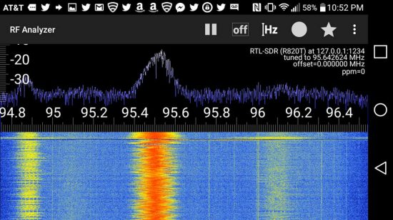
Get a phone-driven signal analyzer cheap, info here.
NO CALL LETTERS
Do not use made up “call signs” (“KLSD”, “WEED”, etc.) You can name your show, but if you give the station zany alphabetical designations that you read out on the air, you’re going to attract more attention by the casual nanny channel surfer as “not legit, let’s listen to this and see if we need to turn them in.”
SISTERHOOD OF THE TRAVELING TRANSMITTER:
Several people in different areas could chip in and buy a system, and each run it for a few months, then pass it on to the next in the group, in a rotation. This would reduce costs, and reduce other issues, too.
LAWS
Don’t break the law. But FYI, if you’re operating on an empty frequency, using a low-pass filter, not cussing, and your programming sounds professional, there’s a very low chance of getting anything more than a cease-and-desist letter. (Broadcasting after that letter can lead to fines.) More here. There are two exceptions, New York and Florida have state laws against unauthorized broadcast. Even so, it’s very rare for first-time “offenders” to get in trouble. Regardless, don’t let anyone in your house without a warrant.
IN CLOSING:
I hope this post helps you in some way. Pass it on if you liked it. Radio is a RIGHT. And it’s plenty of fun for the whole family! Be safe, be legal (the social contract depends on it or we’ll degenerate into anarchy!), and most of all, ENJOY!
–Cash Newmann
Read Lysander Spooner’s “No Treason.”
Turn your cash into liberty!

